Assignment 4: Automatic EBS Snapshot and Cleanup Using AWS Lambda and Boto3
Objective: To automate the backup process for your EBS volumes and ensure that backups older than a specified retention period are cleaned up to save costs.
Task: Automate the creation of snapshots for specified EBS volumes and clean up snapshots older than 30 days.
Instructions:
1. EBS Setup:
- Navigate to the EC2 dashboard and identify or create an EBS volume you wish to back up.
- Note down the volume ID.

Volume id : vol-0e74e36be749078c0, please refer below screenshot.

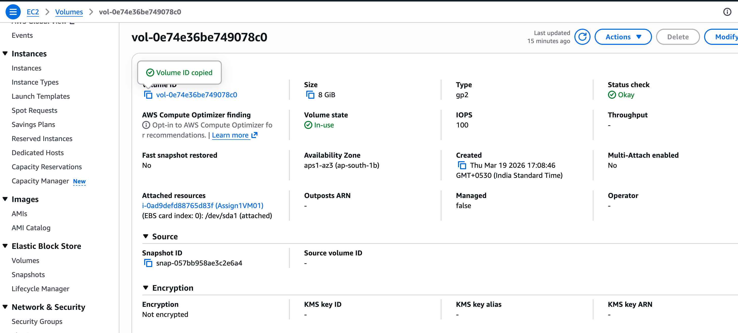

2. Lambda IAM Role:
- In the IAM dashboard, create a new role for Lambda.
- Attach policies that allow Lambda to create EBS snapshots and delete them (`AmazonEC2FullAccess` for simplicity, but be more restrictive in real-world scenarios).

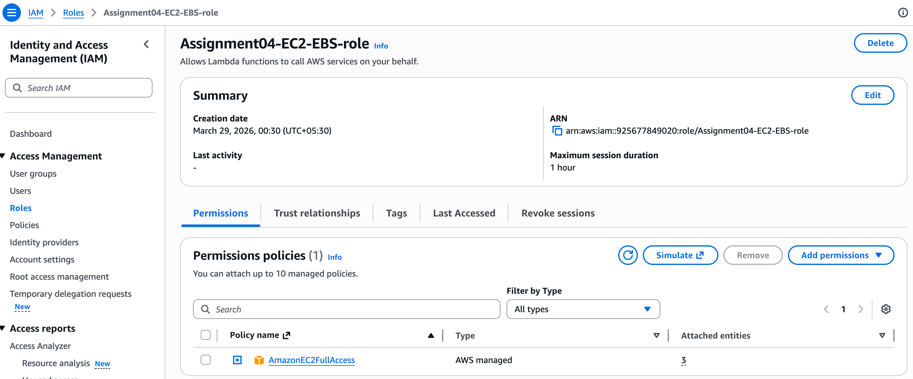

3. Lambda Function:
- Navigate to the Lambda dashboard and create a new function.
- Choose Python 3.x as the runtime.
- Assign the IAM role created in the previous step.
- Write the Boto3 Python script to:
1. Initialize a boto3 EC2 client.
2. Create a snapshot for the specified EBS volume.
3. List snapshots and delete those older than 30 days.
4. Print the IDs of the created and deleted snapshots for logging purposes.

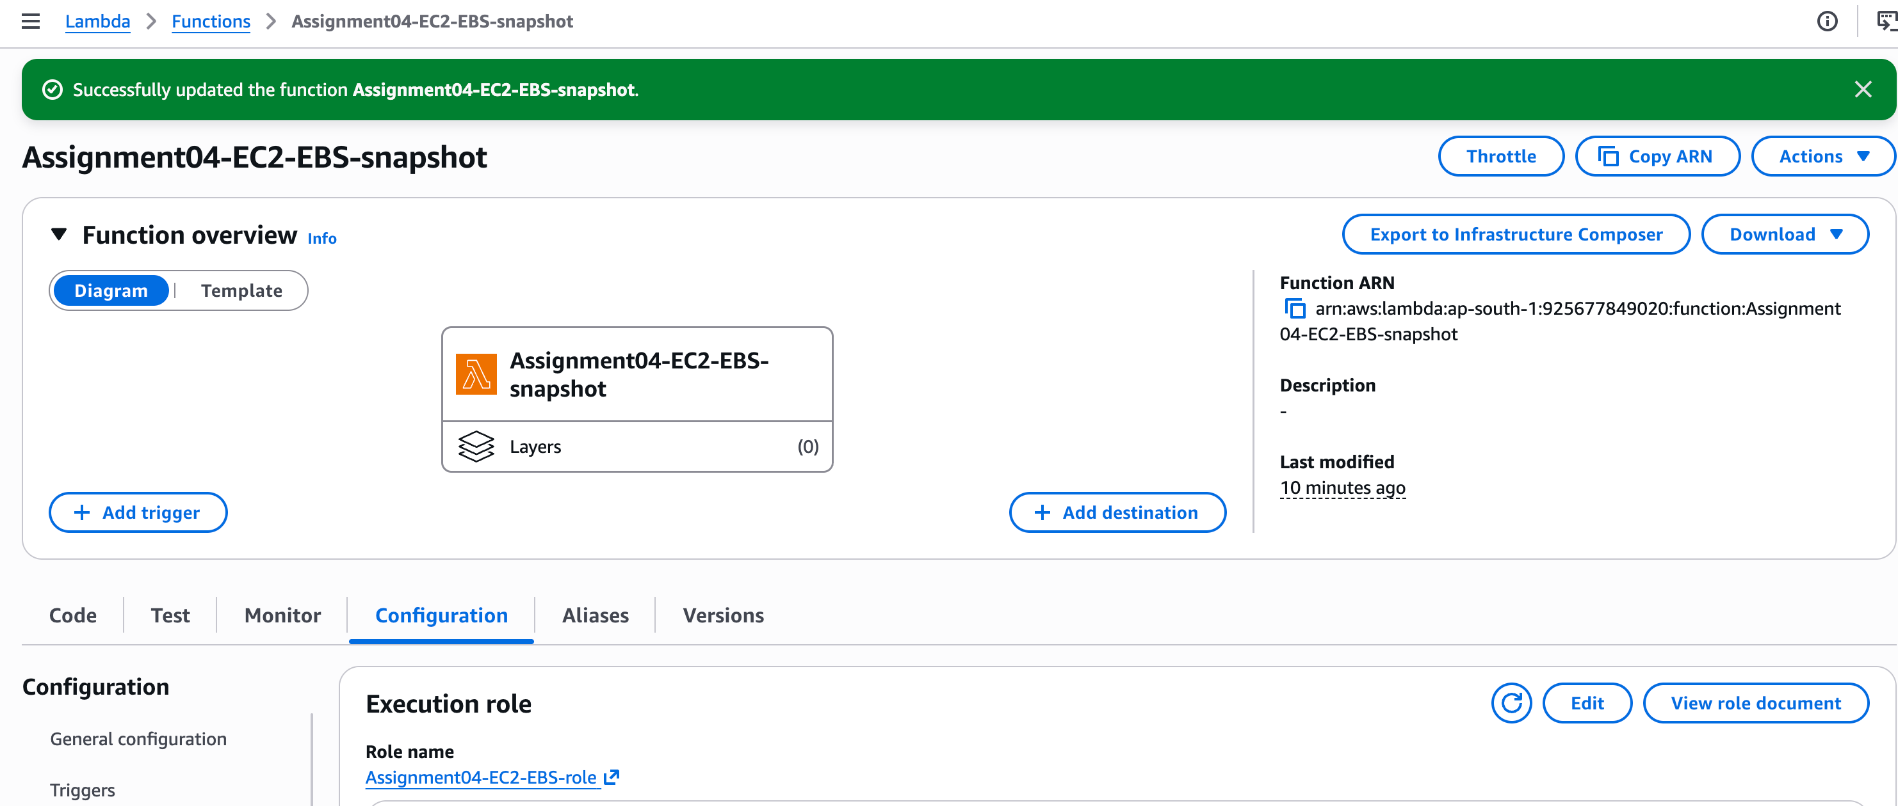

import boto3
from datetime import datetime, timedelta, timezone

ec2 = boto3.client('ec2')

# ===== CHANGE THIS =====
VOLUME_ID = "vol-XXXXXXXXXXXX"

def lambda_handler(event, context):

print("Starting EBS snapshot automation...")

# -----------------------------
# CREATE SNAPSHOT
# -----------------------------
snapshot = ec2.create_snapshot(
VolumeId=VOLUME_ID,
Description="Automated snapshot created by Lambda"
)

snapshot_id = snapshot['SnapshotId']
print(f"Snapshot created: {snapshot_id}")

# Add tag to identify snapshots
ec2.create_tags(
Resources=[snapshot_id],
Tags=[
{'Key': 'CreatedBy', 'Value': 'Lambda-Automation'}
]
)

# -----------------------------
# DELETE OLD SNAPSHOTS
# -----------------------------
retention_days = 30
delete_before_date = datetime.now(timezone.utc) - timedelta(days=retention_days)

snapshots = ec2.describe_snapshots(
OwnerIds=['self']
)

deleted_snapshots = []

for snap in snapshots['Snapshots']:

# Only delete snapshots created by this automation
tags = snap.get('Tags', [])
created_by_lambda = any(
tag['Key'] == 'CreatedBy' and tag['Value'] == 'Lambda-Automation'
for tag in tags
)

if not created_by_lambda:
continue

if snap['StartTime'] < delete_before_date:
ec2.delete_snapshot(SnapshotId=snap['SnapshotId'])
deleted_snapshots.append(snap['SnapshotId'])
print(f"Deleted snapshot: {snap['SnapshotId']}")

print("Automation completed.")

return {
"CreatedSnapshot": snapshot_id,
"DeletedSnapshots": deleted_snapshots
}

4. Event Source (Bonus):
- Attach an event source, like Amazon CloudWatch Events, to trigger the Lambda function at your desired backup frequency (e.g., every week).

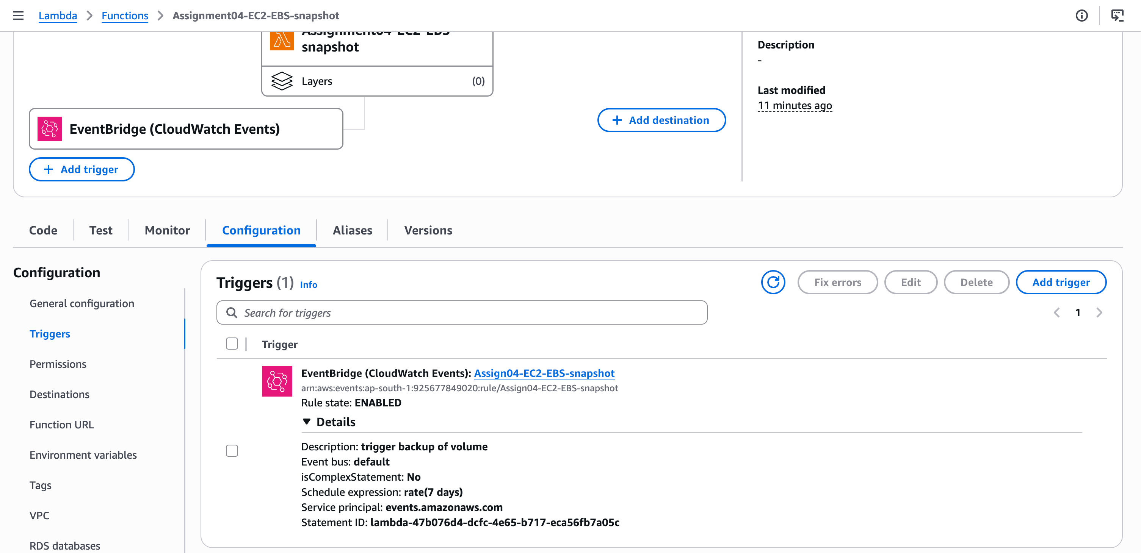
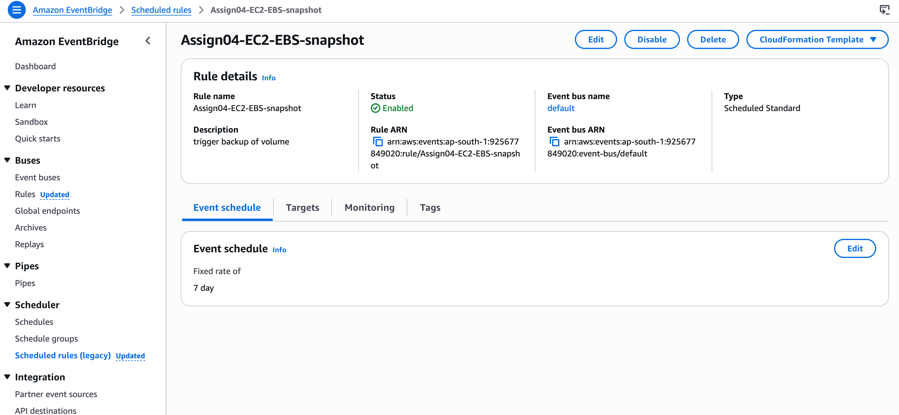

5. Manual Invocation:
- After saving your function, either manually trigger it or wait for the scheduled event.
- Go to the EC2 dashboard and confirm that the snapshot is created and old snapshots are deleted.

